Computer Science

A2 Coursework

Callum Reid

**Investigation Chapter:**

In order to create a reliable system for Bayburn fitness I need to do research to find out what features are required in a system such as mine and what features are perhaps unfavourable to the system. To do this I will be employing several investigation techniques which include Interviews, Questionnaires, Document Collection and Observation. These investigation techniques will allow me to decide what features best compliment the desires of the stakeholders.

**Desk Based Research:**

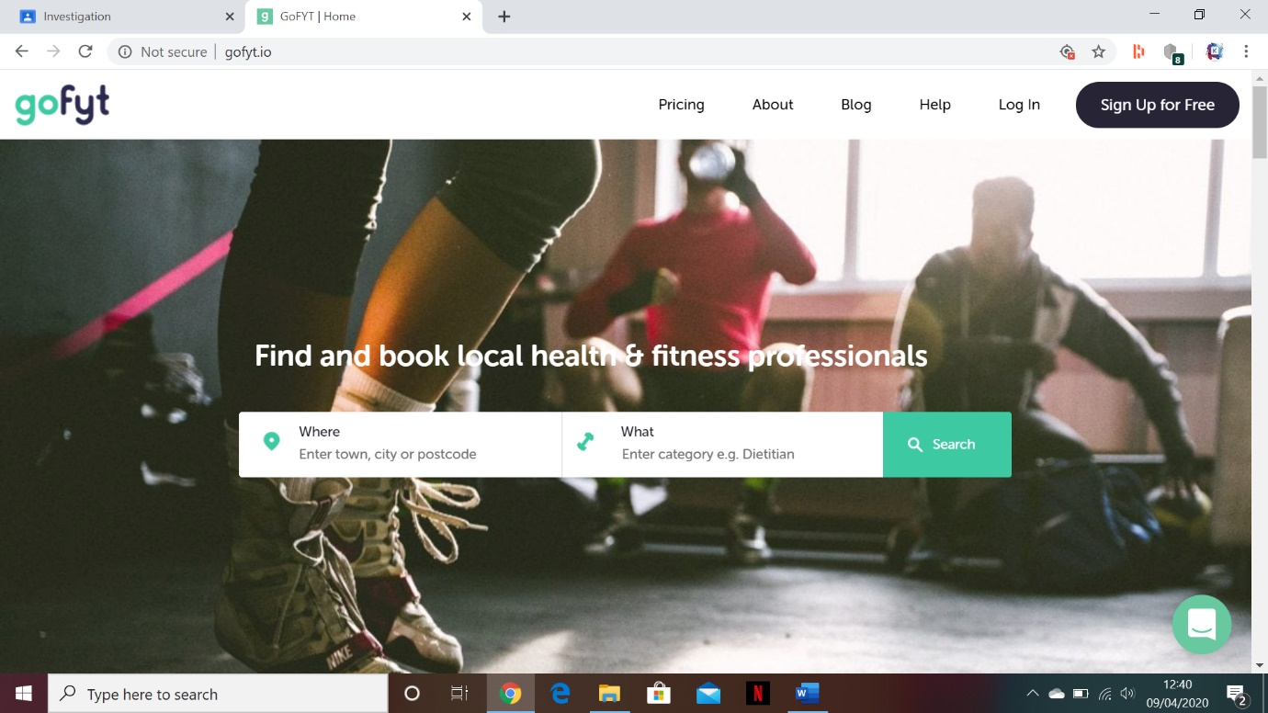Some companies have already developed systems similar to the one which I am proposing. One of these companies is called GoFYT and their system allows small fitness businesses to book appointments with clients for certain things such as classes, personal training, and even sports massages.

GoFYT is an internet-based system and so on their first screen there is useful information that can be accessed and a search system to show you classes based on your location. There is also a login screen for those who have an account or wish to make one.

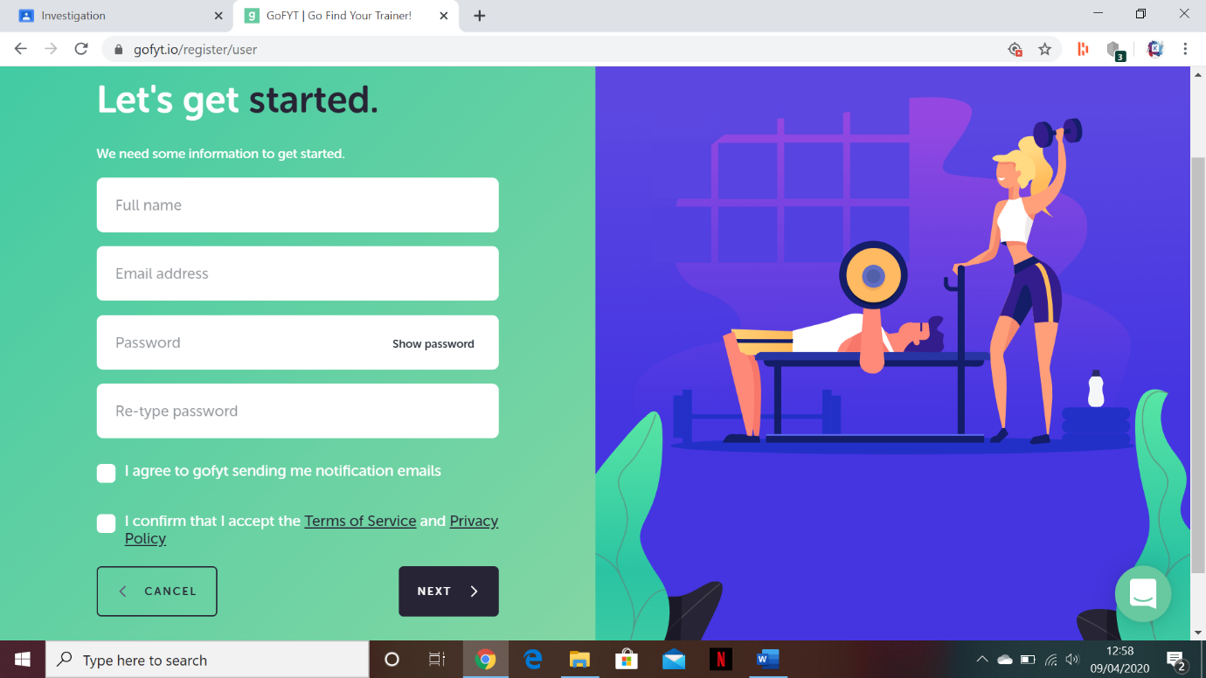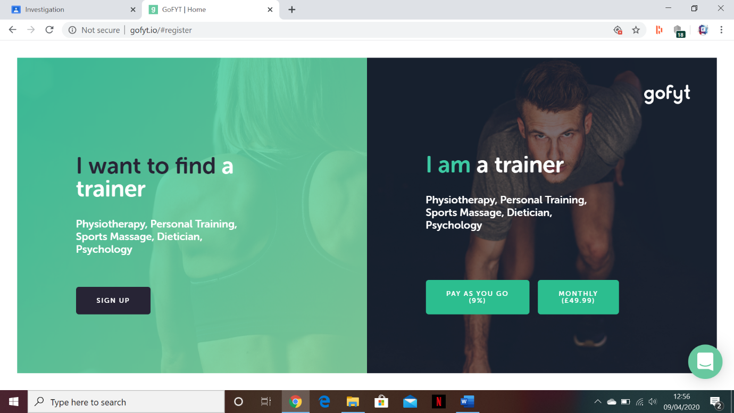 When signing up for an account you are asked if you are a trainer or looking for a trainer. However signing up as a trainer requires a fee.

When signing up as a client you are prompted to enter relevant information and an animated gif plays on the right of the screen which shows how well designed the site is aesthetically.

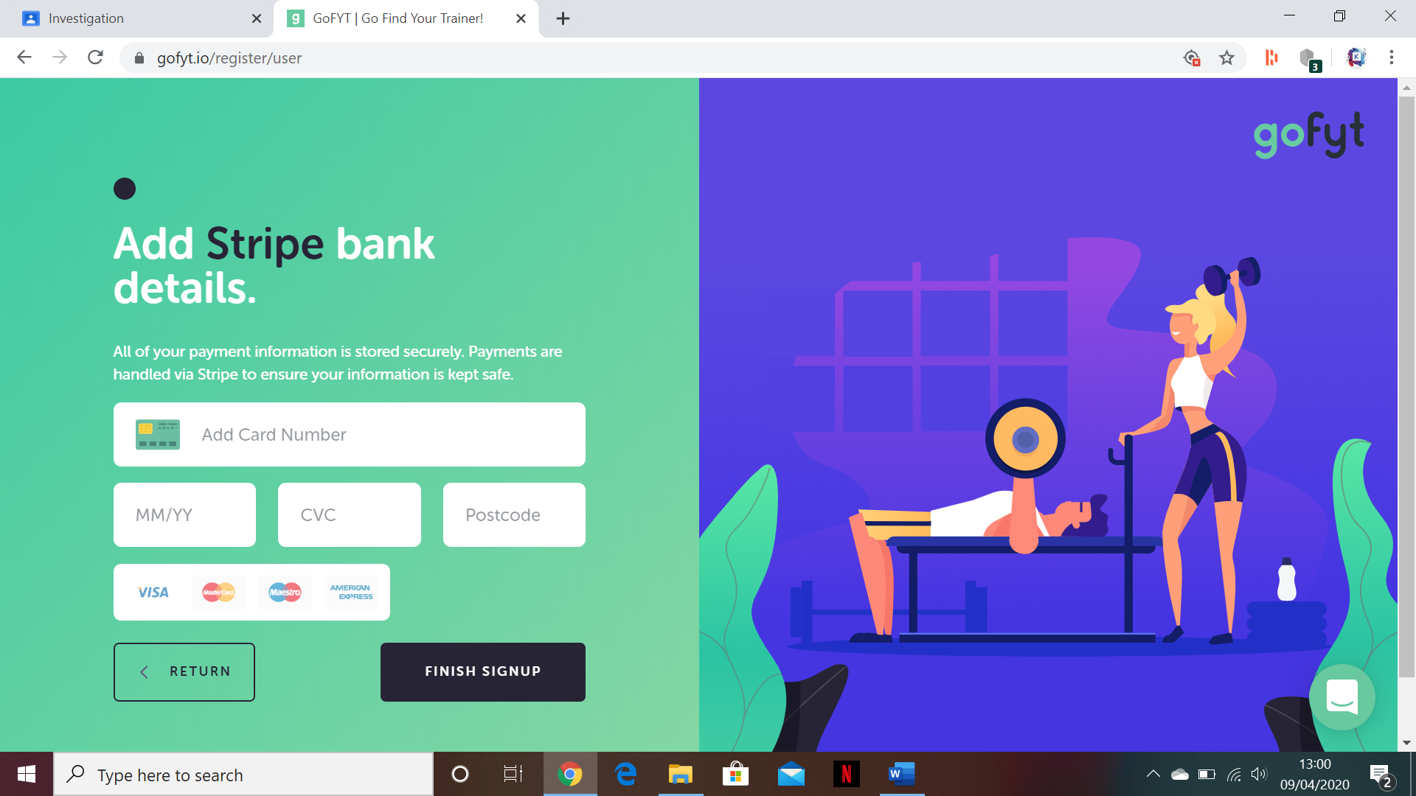

When you add the relevant information and accept to the terms and conditions it asks for payment details.

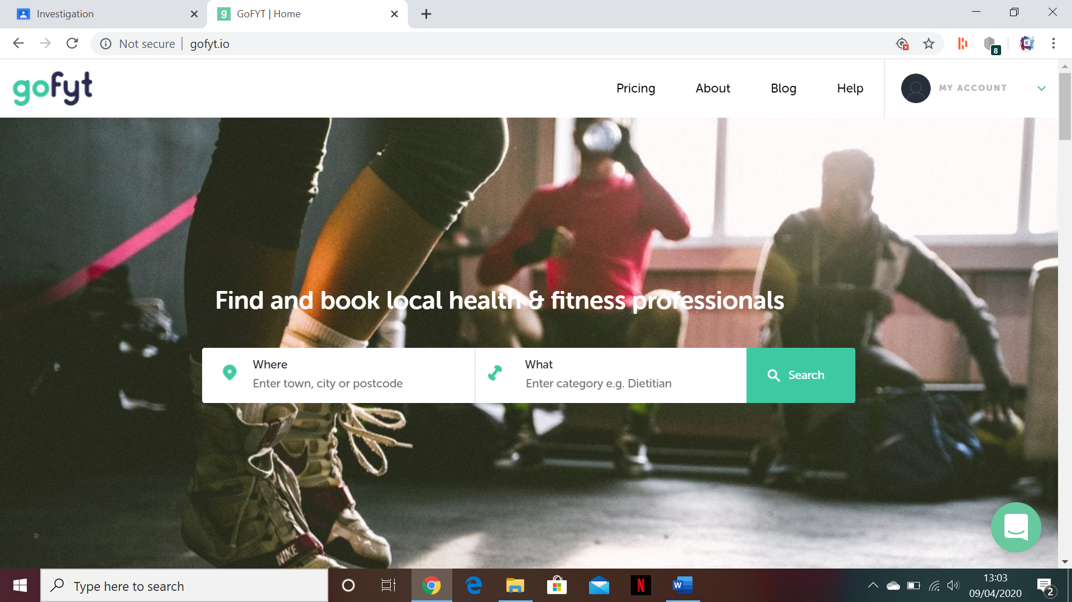

When finished signing up it brings you to a new page where you have access to all the same things as the main page but also your account

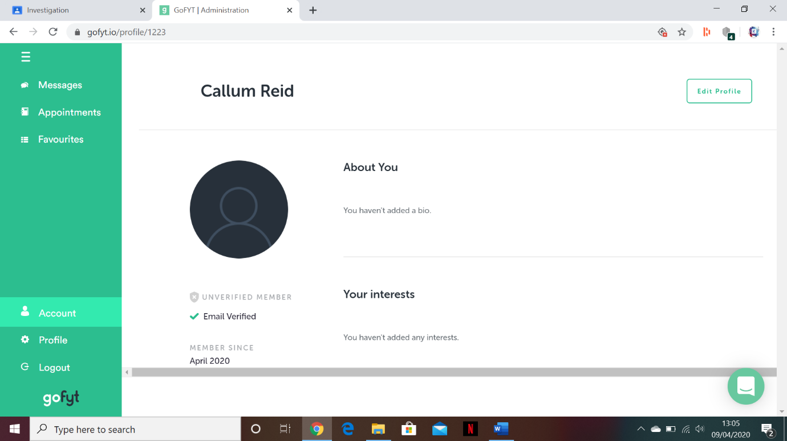when going to my account you have the ability to edit your profile along with viewing all current information that your account holds. You also have access to all the other features such as messages, appointments, favourites and your profile. This screen also allows you to logout.

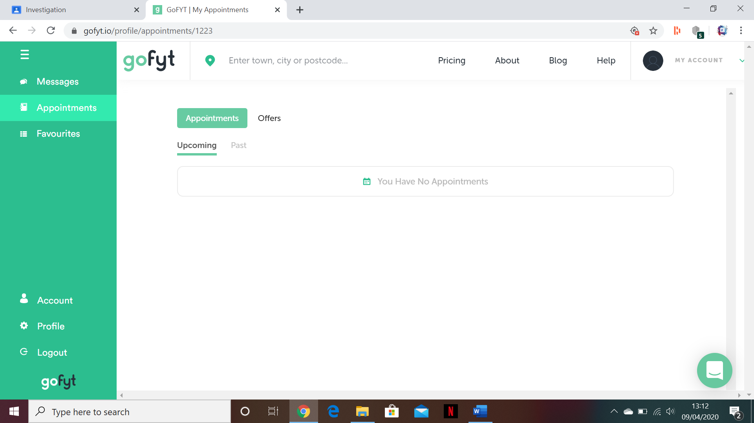

On the appointments tab the user can view any upcoming appointments along with all past ones which they have been to. They can also view offers which allow them to book appointments. Theses offers are found on the main screen when you enter where you live or search for a specific trainer or business.

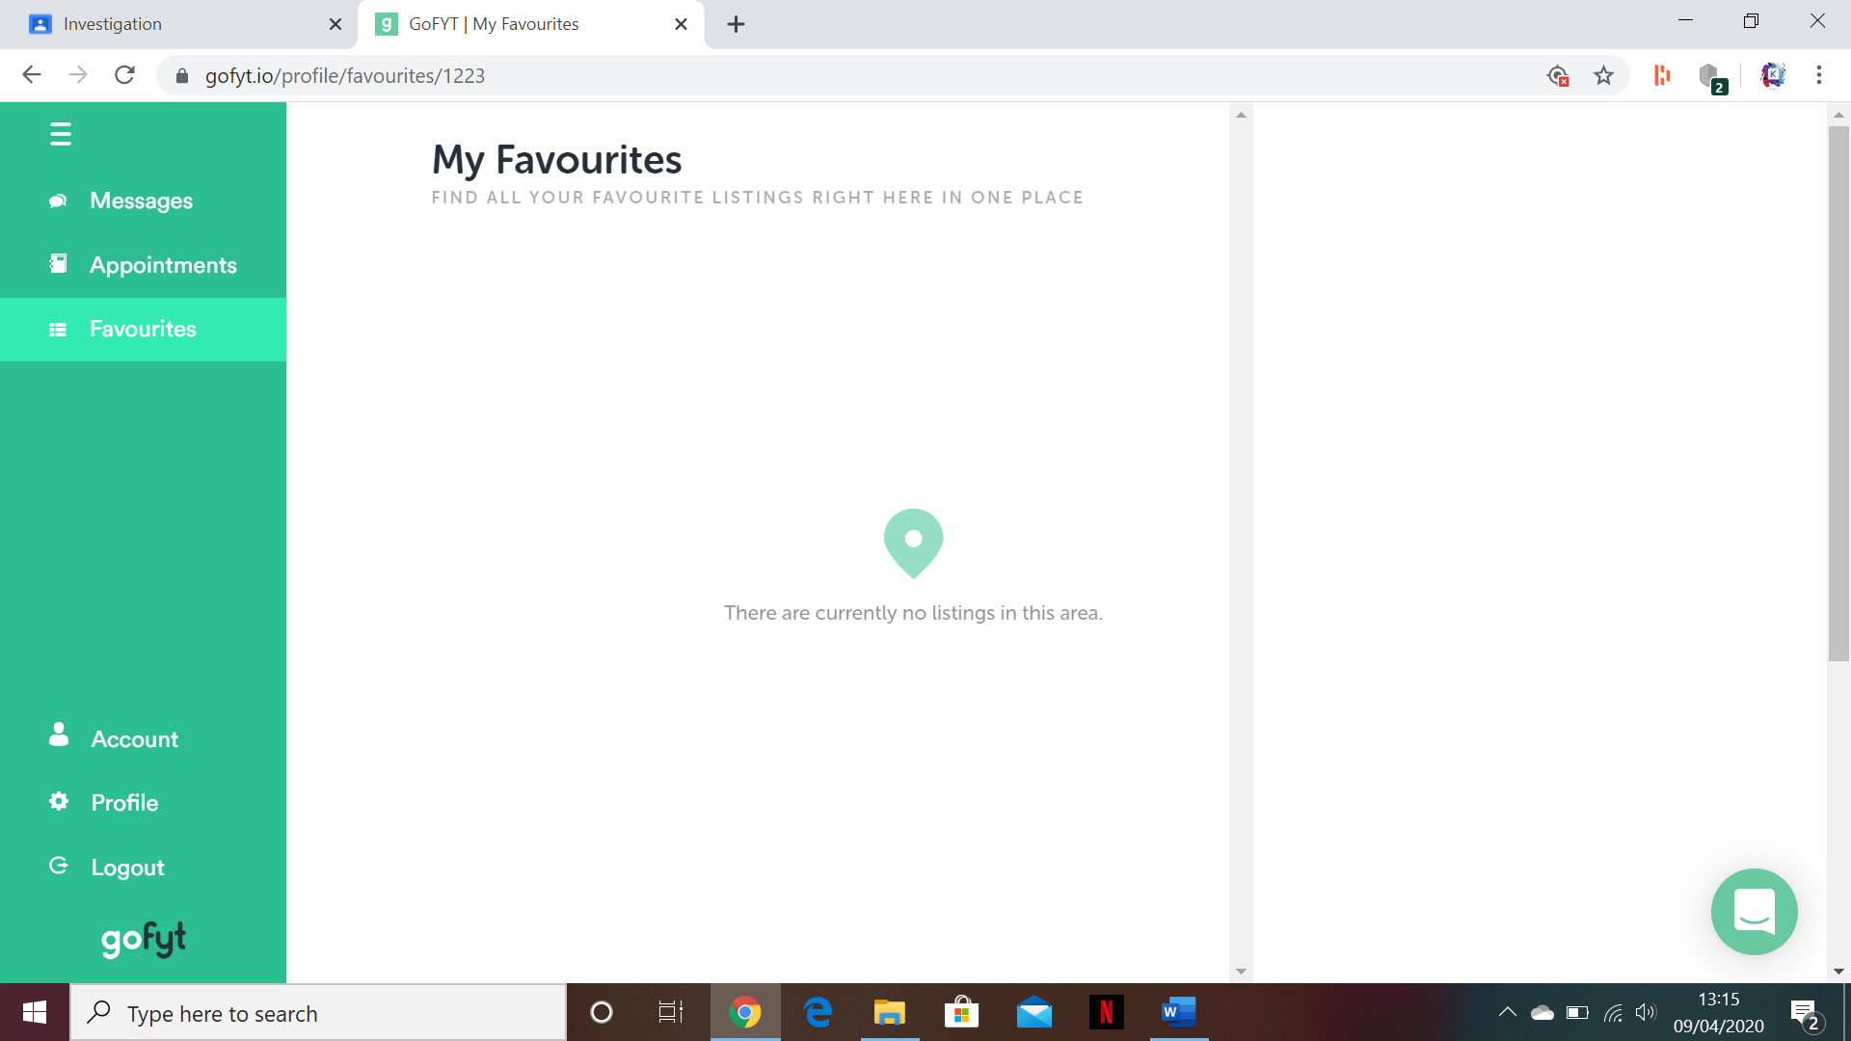

In the favourites tab you are able to see all the favourite listings in your area if you have entered your postcode into your account.

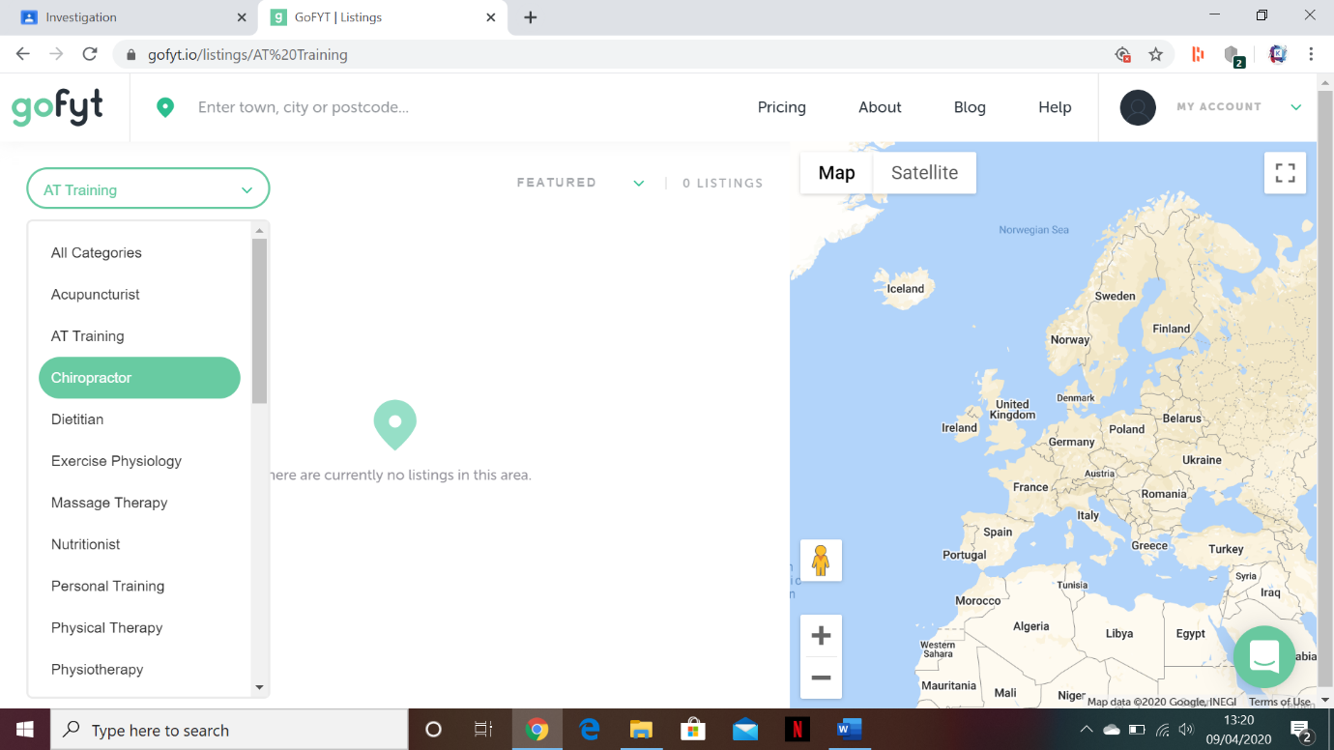when on the main screen you can search for listings based on your location or many categories that can be selected from. GoFYT is relatively new and so it does not have many listings available. When a listing is found it can be added to your offers which can then show you possible appointment times. It also has a map which shows the locations of where these listings are held.

Overall, I think GoFYT is a very intuitive and useful system for the booking of appointments with trainers however it fails to keep track of data regarding personal fitness which is something I want to do with my system.

Strava is a fitness tracking app that is primarily installed on your phone however can be accessed through the internet. It allows sports and activities to be tracked through the use of GPS and keeps track of important information such as times, locations and personal bests.

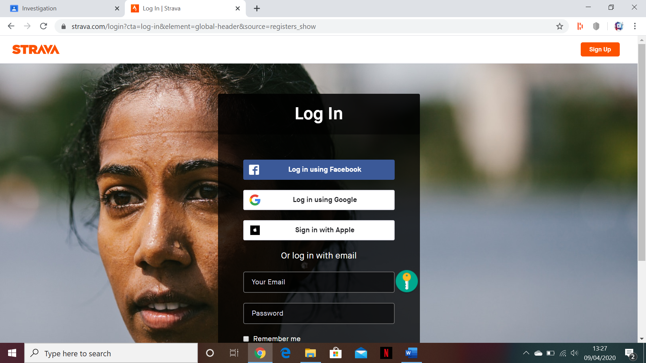

When on the website you are asked to log in or sign up.

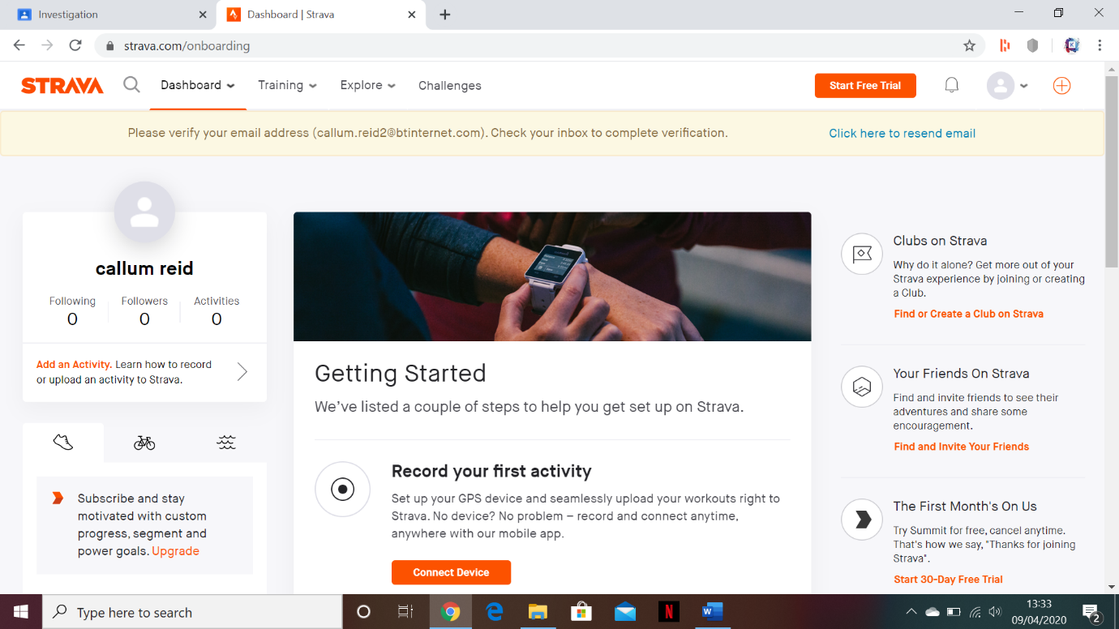when first signed up Strava allows you to record personal fitness activities and post them to your account as a form of social media. It also allows you to follow other people to keep up to date with their fitness.

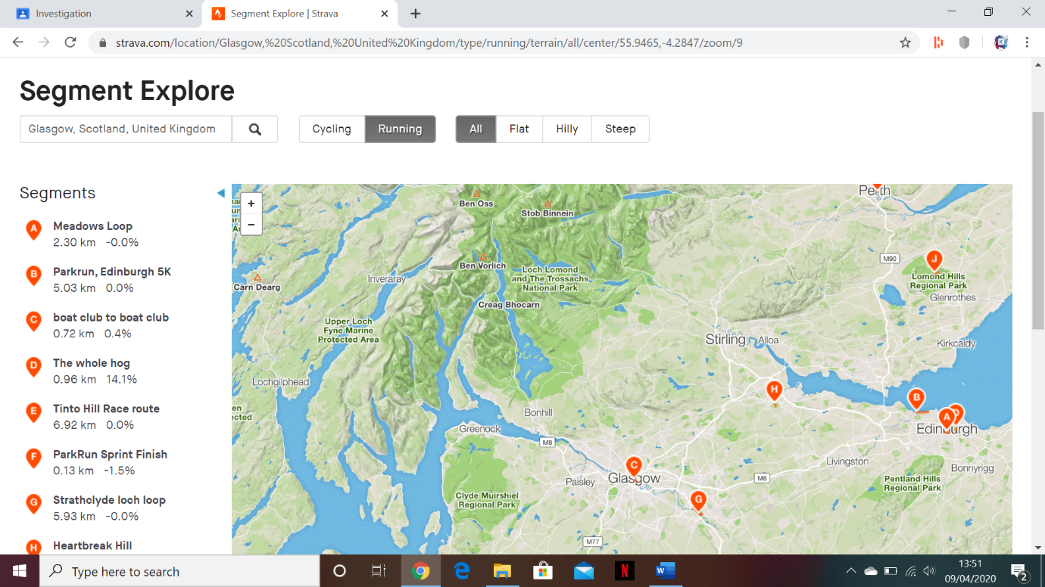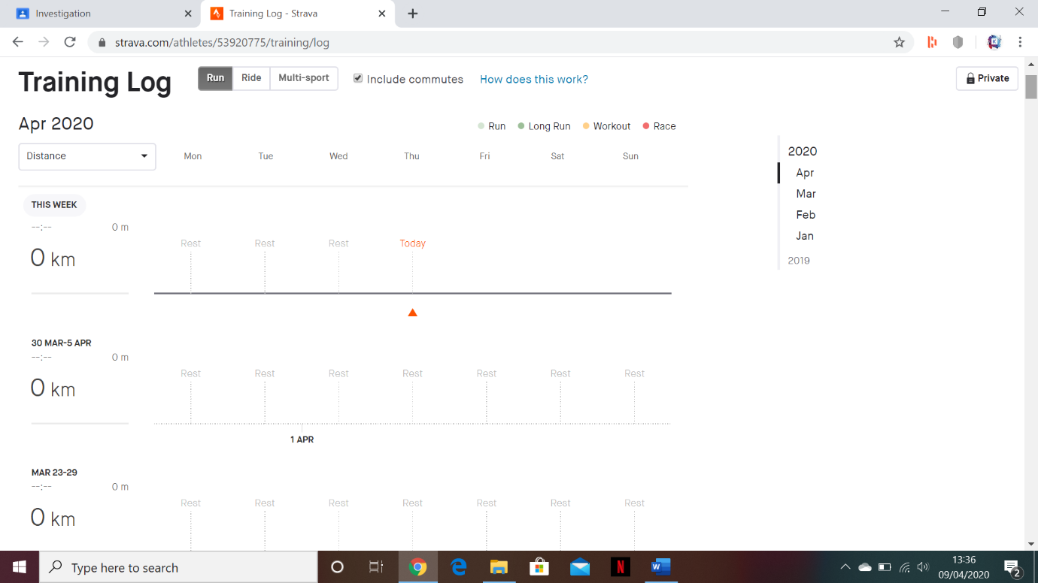in the training log section several graphs can be generated to show your fitness progress over a certain time frame. These graphs can also be used to track multiple different sports including running, swimming, cycling and more.

On the explore page a map can be seen along with all events that are happening in a selected area. This allows clients to monitor what is happening in the fitness world and easily get directions and times for any events that they wish to partake in.

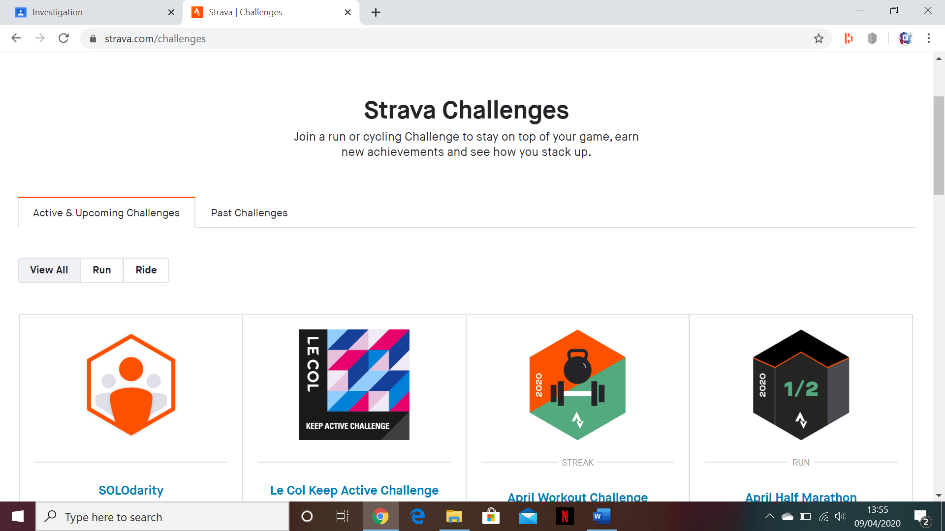

On the challenges screen it shows all challenges that Strava has to offer where the user can either accept or decline them.

Strava is a well-designed system and it picks up where GoFYT left off on being able to track the fitness of a client. It is aesthetically pleasing and has an interesting social media dynamic to it as well.

**Design Concepts:**

From analysing two similar systems I have selected several features I would like to implement into my system:

* A map system which allows clients to see where their appointments are. This feature will make it easy for clients to find where appointments are held.
* An in-depth tracking system for clients to track their fitness progress. This will allow the system to help track a client’s physical fitness as well as help the trainer so they don’t have to remember all of their client’s current abilities.
* A tab-based navigation system where all screens can be accessed at all times. This will make the system more intuitive and easier to navigate by users as all screens can be accessed from any screen.
* Centre screen messages to show when there is no information to be displayed. This will reduce confusion and avoid a blank screen with no text on it.
* Animated GIFs to make the system more aesthetically appealing. This will increase the appeal of the system to all users.
* A single coherent colour scheme. This will also help make the system more appealing aesthetically.
* Buttons That change colour when pressed or when the cursor is hovering over them. This will help with making the system more intuitive and user friendly.
* Pictures to show images that relate to the screen or the system. These could be used to make the screen more aesthetically pleasing or give the user information about what screen they’re on.
* Drop down menus that give the user all possible options for data they could enter into a field. This will reduce the amount of incorrect data entered into the system.
* Error messages which highlight where information has been incorrectly entered or is invalid. This will reduce the amount of incorrect data entered into the system.
* Placeholder text which shows examples of what information should be entered into each field. This will reduce the amount of incorrect data entered into the system.
* Tooltips that give you information about an element of the screen whenever you hover over it. This will make the system more intuitive and easy to use.

**Observation:**

I observed the manager, trainer and myself as a client leading up to and during a class

**Manager:**

The manager first creates a WhatsApp notification (Output) 1 hour before the class begins informing everyone of where the class will be taking place, what trainer will be taking the class, how long the class will be and what type of training we will be doing. People then respond to this with questions and queries (input) which are answered either by the manager or the trainer. When at the class the manager is usually not present and has no further input until the next class however he remains in steady contact with everyone through the WhatsApp group chat (input/Output) and is sure to relay any other information to us such as: cancelations, location changes and special events. The manager also helps organise charity events through WhatsApp (Input) and is usually present on any Saturday classes. The manager is also responsible for handling direct bank transfers and making sure that an excel spreadsheet is up to date with who has paid (input).

**Trainer:**

The trainer is in regular contact with all clients through the use of the WhatsApp group chat (input/output). When people are arriving to the class the trainer marks them down in an excel spreadsheet as having come to that class (input). If the person is paying as they go the trainer collects the money from them and marks them as having paid for their class on the spreadsheet (input). The trainer will also help communicate with clients directly across WhatsApp to specialise classes for their needs, for example, bringing specific equipment for an injured person or changing an exercise to better suit someone. (input)

**Client:**

The client is in regular contact with the trainers and the main manager through the use of the WhatsApp group chat (input/output). The client currently has no way of booking into classes other than saying they will be there in the group chat. The client is responsible for connecting a bank transfer to the manager so that they can pay or they must bring money to every class that they attend if they are paying as they go (input).

**Interview:**

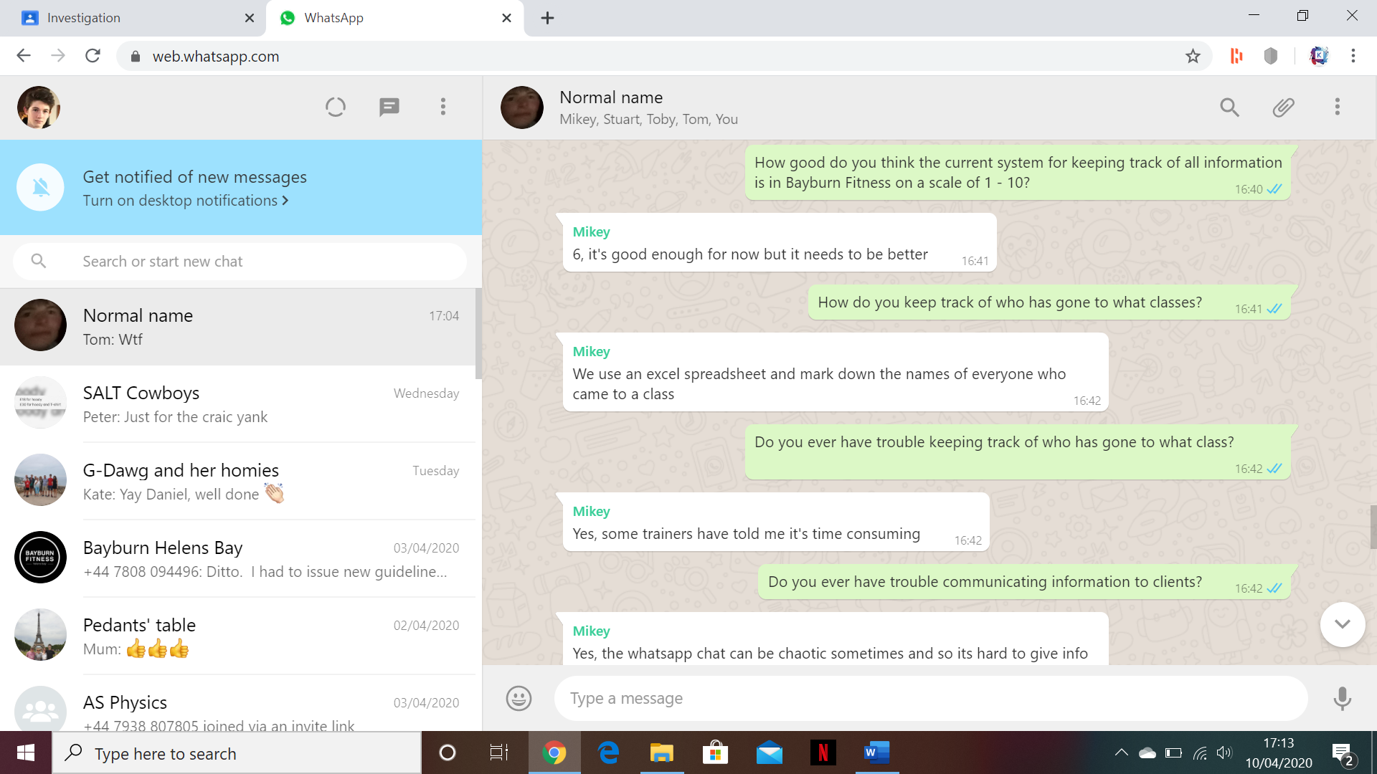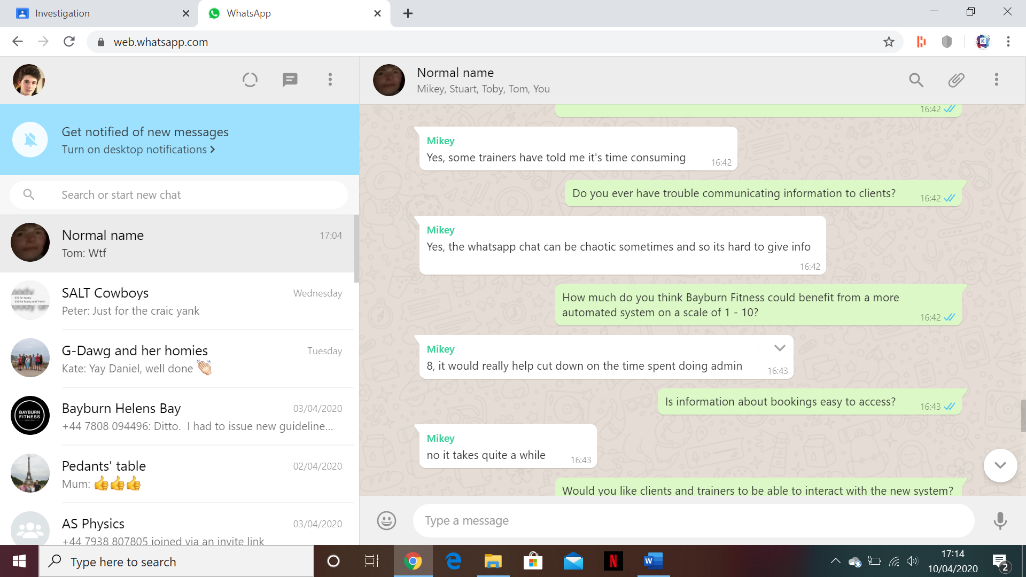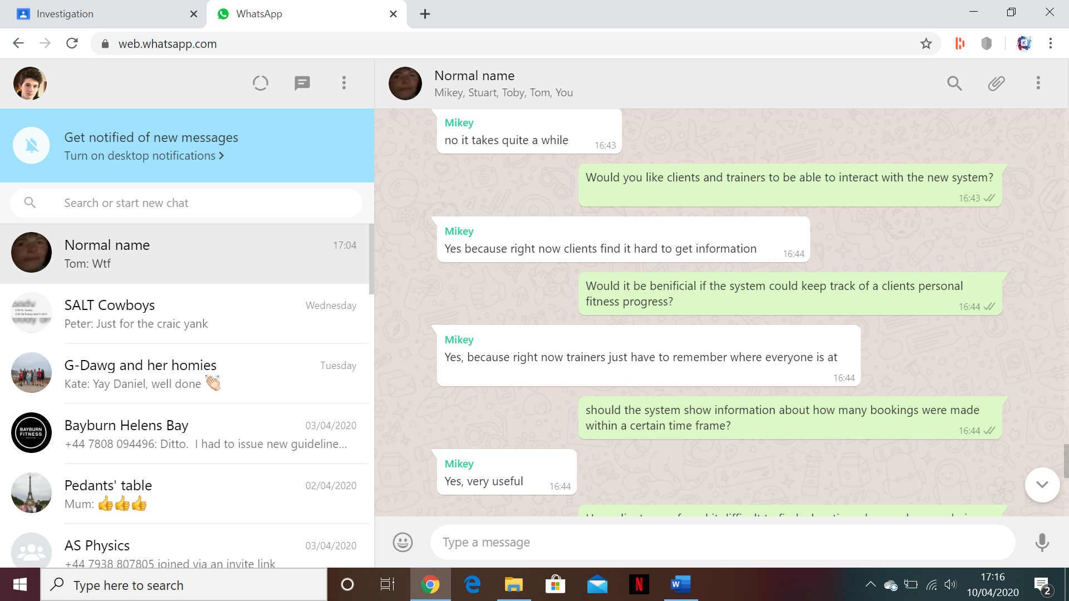The following set of questions were given to the Manager of Bayburn Fitness:

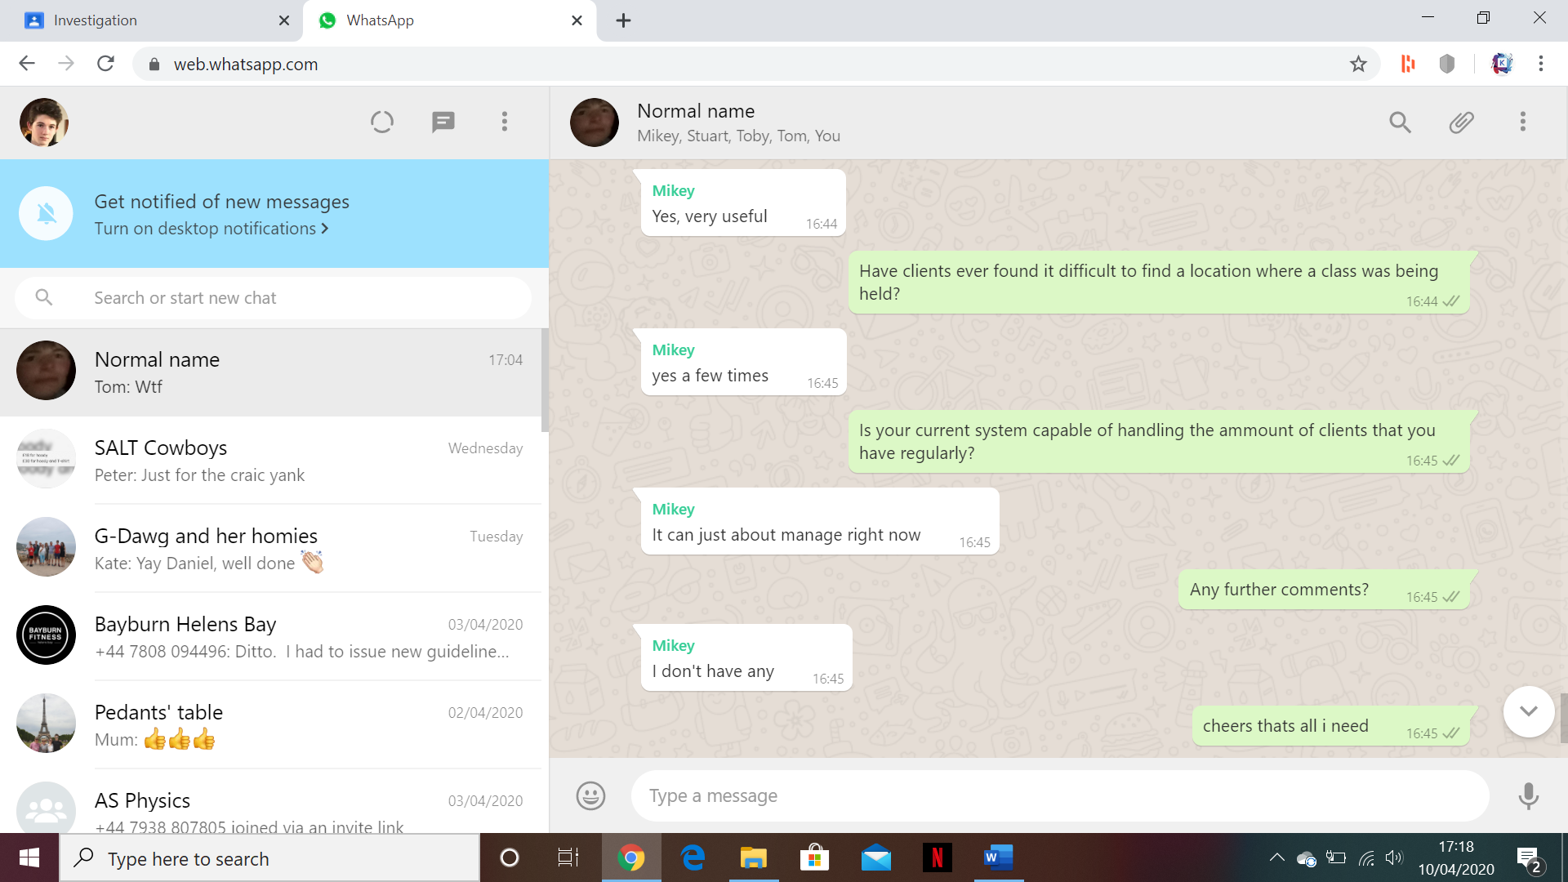

**The following is the analysis of answers given by the manager:**

Q1: How good do you think the current system for keeping track of all information is in Bayburn Fitness on a scale of 1 – 10?

A1: 6, currently the system for keeping track of data is sufficient for their needs however can become messy and will need to be improved as they grow as a company or it will become too cluttered to use.

Q2: How do you keep track of who has gone to what classes?

A2: Trainers use an Excel spreadsheet which has all the classes for that week and next to each class the trainer enters everyone who went to the class and highlights them green if they have paid.

Q3: Do you ever have trouble keeping track of who has gone to what class?

A3: Yes, trainers have said that it takes time to enter all the people who have gone to the class into the Excel spreadsheet which can take time out of the class.

Q4: Do you ever have trouble communicating information to clients?

A4: Yes, there is currently no restriction on who can send messages into the WhatsApp group and so it can become filled with messages and drown out the information.

Q5: How much do you think Bayburn Fitness could benefit from a more automated system on a scale of 1 – 10?

A5: 8, Bayburn Fitness could greatly benefit from a more automated system as it would decrease the amount of time spent entering data and therefore increase the amount of time spent running the classes

Q6: Is information about bookings easy to access?

A6: There is currently no place where booking information is stored, rather a list of people who went to each class is kept on an Excel spreadsheet and they are highlighted green if they have payed for their class.

Q7: Would you like clients and trainers to be able to interact with a new system?

A7: Yes, it would make it far easier for the manager if his trainers could also access the system and if clients could see information that the system provided to them in order to make communication easier.

Q8: Would it be beneficial if the system could keep track of a client’s personal fitness progress?

A8: Yes, keeping track of where each individual client is at in terms of personal bests, maximum weights and best times would be useful as it is impossible for trainers to remember all the information for all the people who go to their classes.

Q9: Should the system show information about how many bookings were made within a certain time frame.

A9: Yes, it would be beneficial for the system to be able to show how many bookings were made in a certain time frame as to see what types of classes sell better and what people are more interested in.

Q10: Have clients ever found it difficult to find a location where a class was being held?

A10: Several clients have told the manager that they found it difficult to find a site when it was their first time attending a class at that site or when a class had to be temporarily relocated.

Q11: Is your current system capable of handling the amount of clients that you have regularly?

A11: The system can just about handle the amount of regular clients that Bayburn Fitness has however eventually there will be too many people to use the current system effectively.

Q12: Any further comments?

A12: No further comment.

**Document collection:**

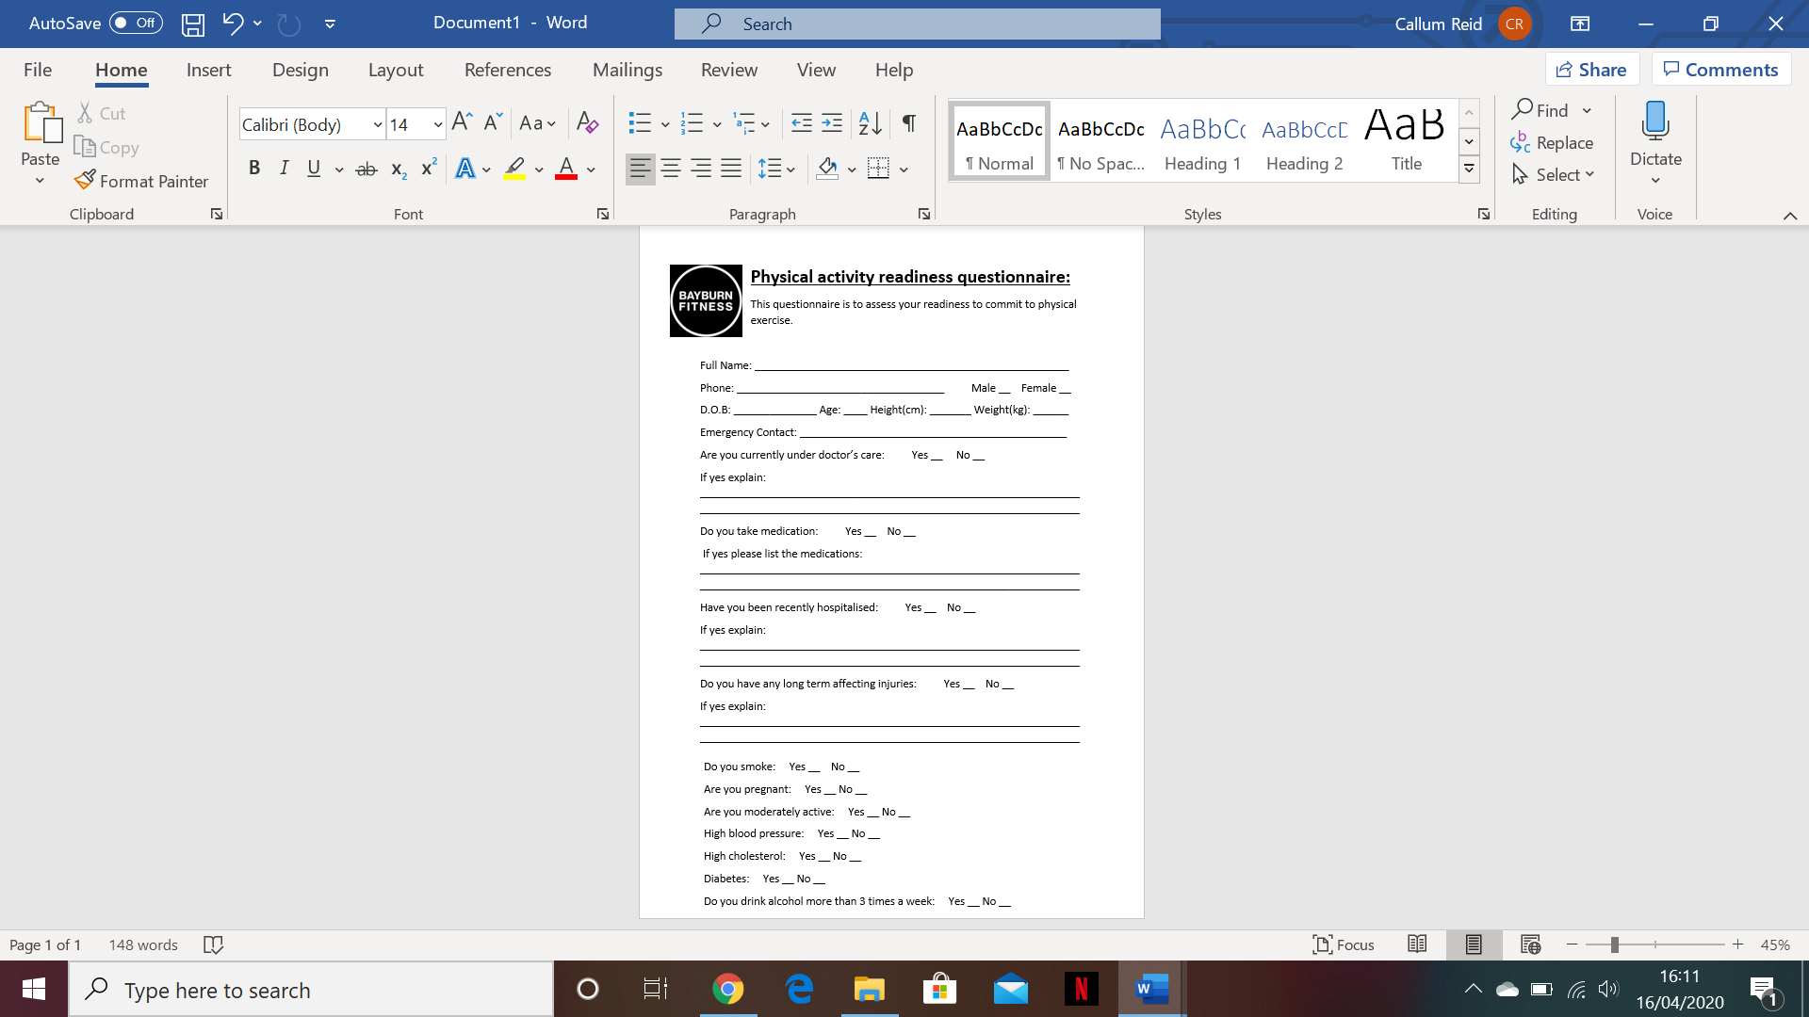This is the Bayburn fitness PAR Q (physical activity readiness questionnaire):

**PAR Q analysis:**

Above is the Bayburn fitness PAR Q which is emailed to people and have to be either edited on the computer or printed out, filled in and scanned before being emailed back to the manager which is a tedious process and takes a lot of time. There also could be many other fields added to this PAR Q however it is constrained by the size of the page. Both of these problems could be rectified with the use of a more automated and computerised system. However, this document does store very personal data and so my system must keep track of it carefully and ensure that nobody but the manager can access it.

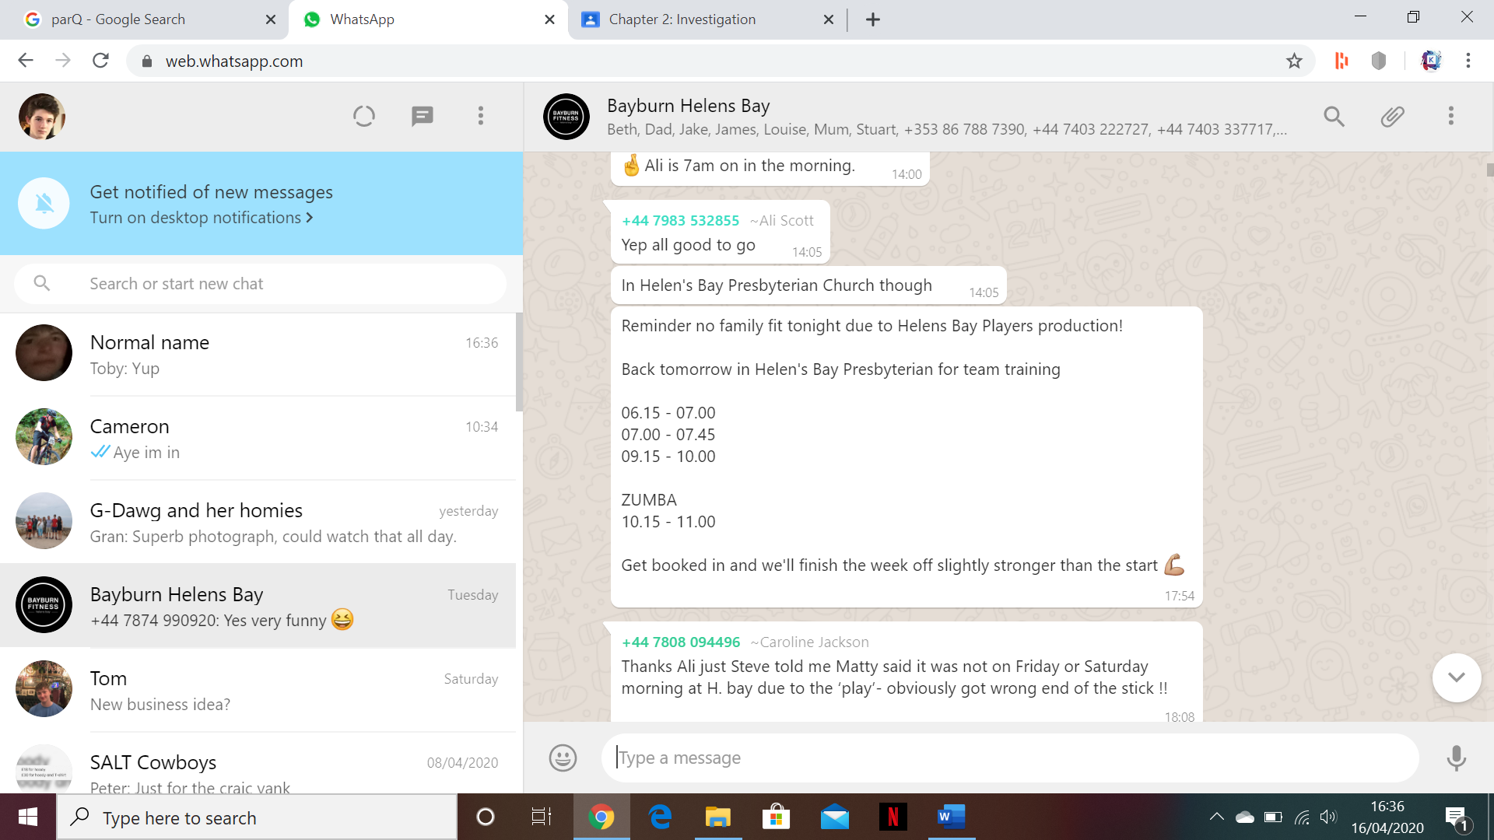

**Notification analysis:**

Above is a WhatsApp message sent by a trainer into the Bayburn Fitness group chat informing people of a cancelation. The message however is hard to find as the WhatsApp chat was very cluttered. The message also requires people to be active on WhatsApp however some people will likely have turned off notifications or may not even have the app installed.

**Questionnaire:**

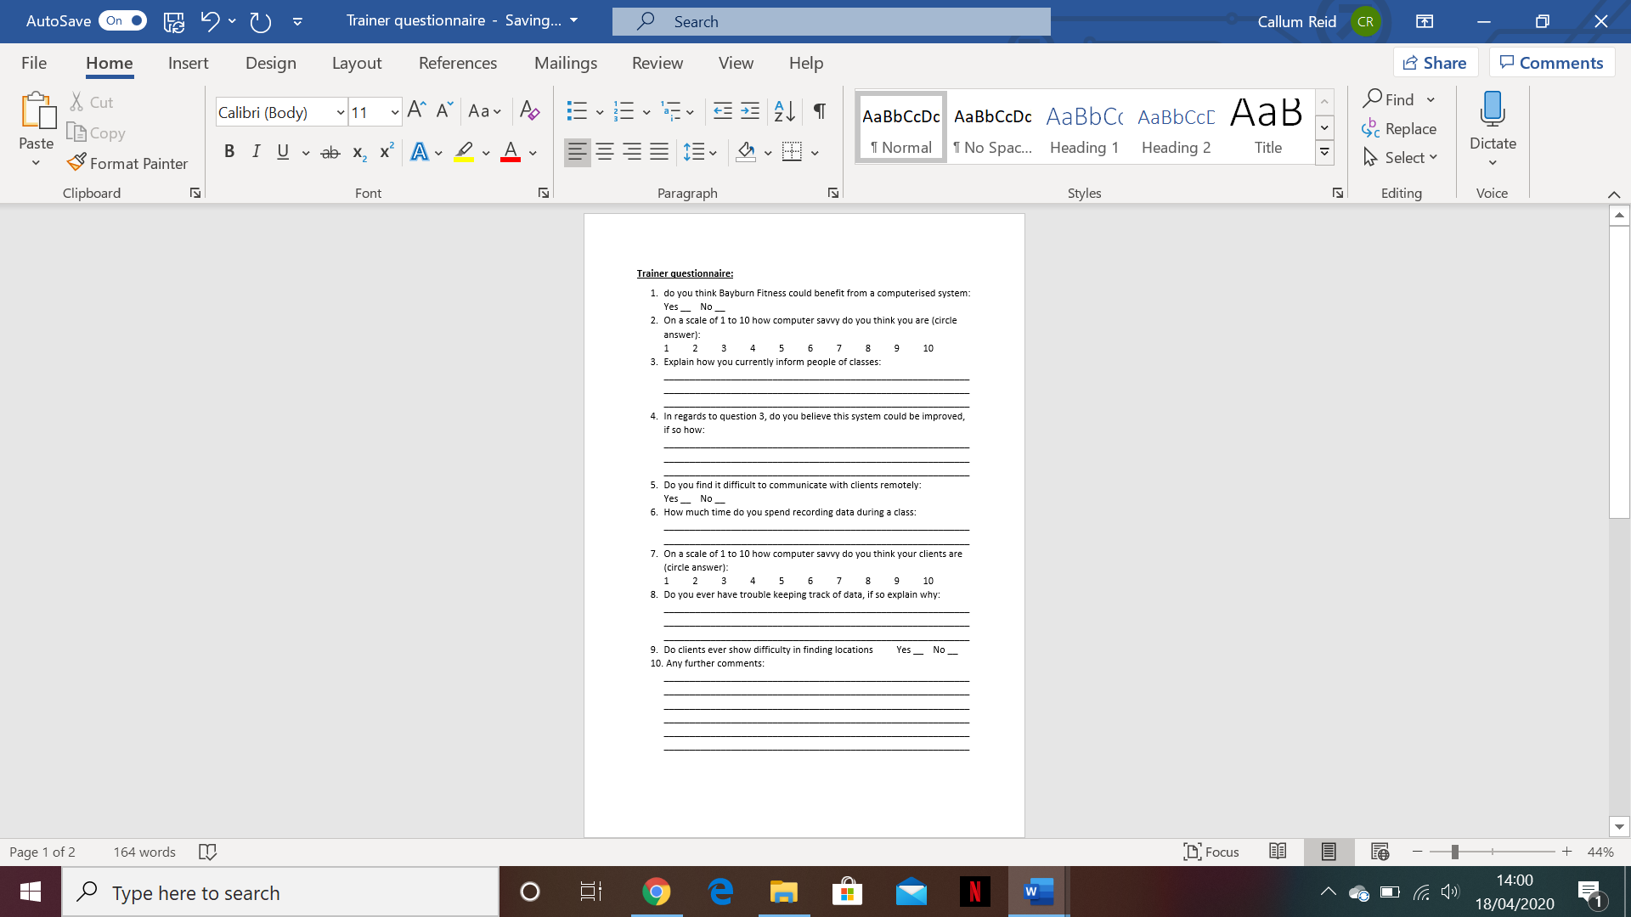Below is a questionnaire I made for the trainers of Bayburn Fitness however I was unfortunately only able to get one of them to fill it out as the rest were in other locations.

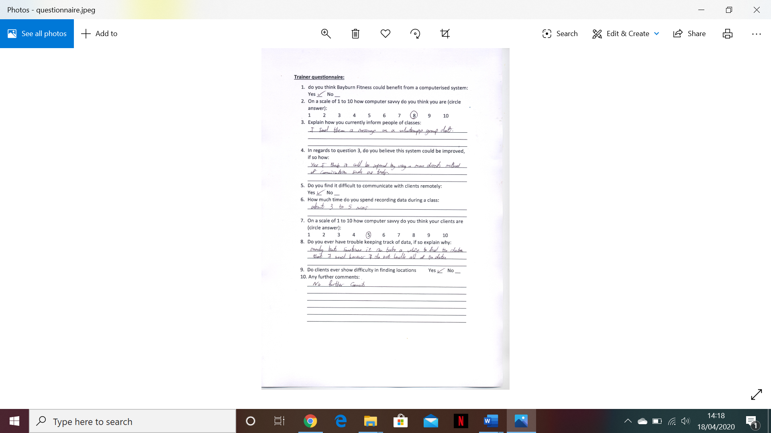

**Trainer questionnaire analysis:**

1. Do you think Bayburn fitness could benefit from a computerised system?

The trainer answered yes which makes it evident that Bayburn Fitness would benefit from a more automated computerised system that could process and store data more readily than the current system that they are employing.

1. On a scale of 1 to 10 how computer savvy do you think you are?

The trainer answered 8 showing that they are quite tech savvy and capable of using a computer for most functions. This shows that if a computerised system were to be implemented the trainers would likely have little trouble using it. However due to the exceedingly small sample size and everyone being different it is difficult to tell if this will be the case for everyone.

1. Explain how you currently inform people of classes.

The trainer answered that they send a WhatsApp message into the group chat so that all clients can see it. This however is not optimal as clients that do not check WhatsApp regularly will not get the notification and if there are many messages being sent into the chat at once the original notification could be drowned out in clutter.

1. In regards to question 3, do you believe this system could be improved, if so how?

The trainer responded that they do think the system could be improved through the use of a more direct method of communication such as text messages. This would be good as text messages are often very hard to miss by clients.

1. Do you find it difficult to communicate with clients remotely?

The trainer answered yes to this question which shows that trainer to client communication is lacking. This is likely due to the difficulty of communicating with someone across a WhatsApp group chat with over 120 participants in it.

1. How much time do you spend recording data during a class?

The trainer answered 3 to 5 minutes which is quite a lot of time considering most classes are about 45 minutes long and have to have a warmup, cool down and explanation to them. This time could be reduced by using a more automated computerised system.

1. On a scale of 1 to 10 how computer savvy do you think your clients are?

The trainer answered 5 which shows that the majority of their clients are tech savvy enough to operate basic functions on a computer and with an intuitive enough system design they should have no problem operating my proposed system solution.

1. Do you ever have trouble keeping track of data, if so, explain why.

The trainer answered that they rarely do however they sometimes spend a lot of time finding data from their database however they also pointed out that they are not fully responsible for the handling of all data. This shows that whilst data ca n be added to the system it takes a while to retrieve it.

1. Do clients ever show difficulty in finding locations?

The trainer answered yes which shows that clients have in the past shown difficulty in finding a location that a class was being held at. This could be rectified through the use of an implemented map in the booking system that a propose for my solution.

1. Any further comments?

The trainer did not have any further comments.

**Client questionnaire:**

I got 25 clients to fill out a 10 question questionnaire and have recorded their answers using visual charts.



**Analysis of client questionnaire:**

1. Do you think the current system for finding and booking classes could be improved?

80% of clients answered that a new system for booking classes would be beneficial to them whilst only 20% liked the current system, this shows a clear need for a new and improved computerized system with more automation.

1. On a scale of 1 to 10 how computer savvy do you think you are?

In this question 3 people answered 10, 7 answered 8, 10 answered 9 and 15 answered 5, this shows that the majority of clients consider themselves to be decently computer savvy and so if my proposed solution is user friendly and intuitive enough there should be no problem with clients navigating and using the system.

1. Do you ever have trouble finding locations of classes?

In this question 75% of clients answered that they had at times found it difficult to find a location where a class had been held. This shows a problem which must be resolved in the new system. I think a good way of doing this would be through the implementation of a map that can direct clients to class locations.

1. Do you ever find yourself in a class that you do not feel comfortable in due to miscommunication?

Only 28% of clients that took the survey found themselves in a class that they felt uncomfortable in however due to the small sample size compared to the overall amount of clients that attend Bayburn Fitness classes we cannot rule out this is a possible problem.

1. Do you think it would help if text messages were sent to your number to give information?

In this question 88% of clients answered yes, this large majority of people shows that having a built-in text message system in my proposed solution would likely be highly beneficial to the solution.

1. On a scale of 1 to 10 how well do you think information is communicated to you?

In this question 2 people answered 9, 3 people answered 7, 5 people answered 10 and 15 people answered 5. This shows that the majority of people believe that the quality of communication between the trainers/managers and them is rather average and could be improved. This is something that my proposed solution will aim to do.

1. How effective do you think the WhatsApp group chat is?

In this question 16% of clients said that the WhatsApp chat was completely ineffective, 8% said that it was ineffective, 48% said that it was effective and 28% said that it was completely effective, I think this shows a pretty varied response and considering the small sample size compared to the total number of clients I think that this must be considered as a problem.

1. Do you think the system could benefit from the implementation of a map feature?

In this question 86% of clients answered that they do think they would benefit from the implementation of a map system, this is good as I do have plans to implement one into my final system.

1. Do you think the system could benefit from the implementation of a fitness tracking feature?

52% of clients answered that they do think a fitness tracking system would be beneficial, because of this I think it would be good to implement a fitness tracking feature into the final system as part of my solution.

1. Do you think the system could benefit from the implementation of an in-built messaging system?

In this question 76% of all clients who took the survey answered they do think that the implementation of a built in messaging system would be beneficial, as a result I am going to implement one into my final system.

**Current list of inputs and outputs**

**Manager Inputs:**

* Person first name
* Person last name
* Person date of birth
* Person phone number
* Person email
* Person gender
* Person role
* Person postcode
* Person address
* Person username
* Person password
* Trainer/manager qualifications
* Trainer/manager past experience
* Client underlying illnesses
* Client recent injuries
* Client height
* Client weight
* Client smoke?
* Client fitness level
* Search first name
* Search last name
* Search ID
* Message info

**Trainer inputs:**

* Class start time
* Class duration
* Class days
* Class overview
* Message info

**Client inputs:**

* Alert time
* Alert type
* Message alert type
* Exercise
* Weight
* Reps
* Sets
* Time

**Manager outputs:**

* Person search results
* Trainer messages
* Trainer attendance graph/report
* Attendance vs time graph/report
* Attendance (last 30 days) graph/report
* Attendance vs class type graph/report
* Client exercise graphs/reports

**Trainer outputs:**

* Previously created classes
* Manager messages
* Upcoming classes
* Upcoming class attendances

**Client outputs:**

* All classes
* Booked classes
* Trainer/manager messages
* Exercise graphs
* Exercise reports

**List of current processes:**

**Manager:**

* Add person
* Search person
* Delete person
* Edit person
* Send message
* Delete message
* View message
* Show graphs
* Generate reports

**Trainer:**

* Create class
* Delete class
* Send message
* Delete message
* View message
* View upcoming classes and attendance
* Record clients as present

**Client:**

* Create booking
* Select alert type and time
* View message
* Select message alert type
* Record performance
* View performance graph
* Generate performance report

**Justification of methods:**

**Language:**

For my system I will be coding in python 3.8, I use this as it is one of the latest versions of python and python is the programming language in which I am most familiar. I have an in depth understanding of python and find it easy to use, another benefit with python is its vast array of pre-programmed libraries that can be installed and used very simply. With the use of libraries in the past I have been able to do almost anything using python, from editing text files to creating midi files that can be played through music software. This shows the vast capabilities of python as a modern programming language, this along with my familiarity with it is why I am choosing it to programme my system with.

**Paradigm:**for my system I will be programming mainly in the procedural paradigm with a partial amount of object oriented. Mainly I will be using procedural programming as it is the programming paradigm in which I am most familiar, it is relatively simple allowing you to make functions with parameters and returns which can be called at anytime from anywhere in the programme. I do however use object oriented programming to a limited extent, however this is usually restrained to creating custom tkinter classes such as date pickers and hover buttons for the graphical user interface of my system. Primarily I restrain myself to using procedural programming and using functions to create the functionality necessary for my system.

**user interface:**

There are two options for a user interface which I could use: a command line interface, or a graphical user interface. A CLI is a very simple type of interface which involves information being displayed on the screen in the form of text and the user inputting text into the command line in order to navigate the system and input commands or information. This type of interface however is not very user friendly and is not at all aesthetically pleasing and as such I will be using a GUI for my system. A GUI is a graphical user interface which is made of many elements placed on the screen for the user to interact with. These elements may include entry boxes, labels, drop down menus, buttons and other elements. GUI’s also allow for the addition of elements that are purely aesthetic and as such a GUI is far more aesthetically pleasing and has the potential to be far mor user friendly than a CLI which is why I am picking it.

**Data storage:**

There are several options for data storage when creating a system however I am going to be using a relational database to store my data. A relational database is a collection of tables which are connected together through the use of primary and foreign keys. This allows for data to be stored in a simple way which allows for it to be easily accessed. There are several reasons I have chosen a database over other data storage methods: the first reason is that by implementing a relational database well, the flow of data can be refined and simplified to make the process of entering and extracting data to or from the database easy. Another reason I am using a database is because the transfer of data can be encrypted and the database itself can be locked so that unauthorised people cannot access it. This is useful as my system will be storing sensitive personal health information which must be held securely. Overall I am choosing a database system as it provides the easiest and most effective means of data storage for my system.

**Summary of the purpose of the project:**

After extensive investigation, feedback, and insight I now fully understand the purpose of the project in relation to each individual stakeholder. This purpose will be outlined below for the stakeholders:

**Managers:**

One purpose of the system will be to allow managers to add, edit and delete trainers and clients from the Bayburn Fitness roster quickly and efficiently. Another purpose of the system will be to allow the manager to generate extensive reports about how many classes have been attended, what classes have been attended along with who has paid for their classes and who has not as to help refine the payment system for the managers. The final purpose of the system for the managers will be to streamline and automate communication between managers, trainers and clients through the use of a message board, emails, and text messages.

**Trainers:**

One purpose of the system will be to allow trainers to automate and streamline the scheduling of classes for clients to book into. Another purpose of the system will be to greatly reduce the amount of paperwork a trainer will need to do in terms of recording attendance in classes and keeping track of payments. The final purpose of the system for the trainers will be to streamline and automate communication between trainers and clients through the use of a message board, emails, and text messages.

**Clients:**

One purpose of the system will be to allow clients to easily book into classes created by trainers and be given full information on what will take place in those classes. Another purpose will be to allow a client to track their fitness, the fitness tracking aspect of the system will allow clients to track individual aspects of their fitness as well as set targets, the tracking information will also be displayed graphically. The final purpose of the system for the clients will be to streamline and automate communication between trainers, managers and clients through the use of a message board, emails, and text messages.

**Objectives and success criteria:**

The following points outline the different objectives I have for the system relating to each stakeholder along with success criteria to decide whether or not this objective has been completed.

**All stakeholders:**

**Objective: -** create an intuitive GUI through which my system can be navigated.

**Success Criteria: -** all stakeholders are pleased with the system’s GUI and require no external training to use it.

**Objective: -** create a login system that gives each stakeholder their individual levels of access.

**Success Criteria:** **-** all stakeholders can log In and when they do, they have the correct level of access.

**Objective: -** create a system that connects to a database which stores all necessary data.

**Success Criteria:** **-** all data that is recorded or generated by the system is stored in a separate database that communicates with the system.

**Objective: -** create a system that keeps all data belonging to stakeholders secure.

**Success Criteria:** **-** all data that is transferred between the system and the database is encrypted.

**Objective: -** create a system that keeps human error to a minimum by validating inputs.

**Success Criteria:** **-** all inputs into the system are validated and where possible selection is used over entry.

**Objective: -** create a system that allows for easy remote communication between stakeholders.

**Success Criteria:** **-** all stakeholders confirm that they can easily communicate with each other remotely through the system.

**Objective: -** create a system that improves the overall experience of being a part of Bayburn Fitness.

**Success Criteria:** **-** all stakeholders confirm that their experience in being a part of Bayburn Fitness has been improved by the system.

**Managers:**

**Objective: -** create a system that allows managers to add, edit and delete stakeholders from the system with ease.

**Success Criteria:** **-** the managers confirm that it is easy to add, edit and delete stakeholders.

**Objective: -** create a system that can greatly improve communication between managers and trainers/clients.

**Success Criteria:** **-** all managers have confirm that communication between them and the trainers/clients has been greatly improved by the system.

**Objective: -** create a system that allows a manager to generate in depth reports on class attendance and who has payed for their classes.

**Success Criteria:** **-** all managers are capable of generating reports which show all relevant information about class bookings and payments in depth.

**Objective: -** create a system that reduces the amount of overall paperwork needed to be done by a manager.

**Success Criteria:** **-** all managers confirm a reduction in paperwork as a result of the new system.

**Objective: -** create a system that allows managers to access the information associated with any individual client or trainer.

**Success Criteria:** **-** all managers confirm that they can easily access data of any individual trainer or client.

**Objective: -** create a system that improves the organisation and availability of data

**Success Criteria: -** all managers confirm that data is organised more efficiently and is readily available.

**Trainers:**

**Objective: -** create a system that allows trainers to create, edit and delete classes with ease.

**Success Criteria:** **-** all trainers confirm that they can easily create, edit and delete classes.

**Objective: -** create a system that allows trainers to communicate easily and remotely with clients and managers.

**Success Criteria:** **-** all trainers confirm that the communication between them and managers/clients has been improved.

**Objective: -** create a system that allows a trainer to view all of the people who have booked into their classes.

**Success Criteria:** **-** all trainers confirm that they can easily see which clients have booked into the classes that they have made.

**Objective: -** create a system that allows a trainer to record the attendance of clients who book into classes.

**Success Criteria:** **-** all trainers confirm that they can easily record which clients out of the ones that booked into a class, actually attended the class.

**Objective: -** create a system that reduces the overall amount of paperwork that has to be done by a trainer.

**Success Criteria:** **-** all trainers confirm that the amount of paperwork that they have had to do has been reduced due to the system.

**Objective: -** create a system that informs the trainer of specific events via email or text.

**Success Criteria:** **-** all trainers confirm that they can receive emails or texts to notify them of events.

**Clients:**

**Objective: -** create a system that allows clients to book into classes that have been created by trainers.

**Success Criteria:** **-** all clients confirm that they are able to book into classes that have been created by trainers.

**Objective: -** create a system that allows clients to easily communicate with managers and trainers.

**Success Criteria:** **-** all clients confirm that they are easily able to remotely communicate with managers and trainers.

**Objective: -** create a system that allows clients to easily track their fitness progress.

**Success Criteria:** **-** all clients confirm that they are able to easily track their fitness progress using the system.

**Objective: -** create a system that contributes to the overall fitness of a client.

**Success Criteria:** **-** all clients confirm that their fitness level has increased since the system was implemented.

**Objective: -** create a system that allows clients to be notified of events via emails and text messages.

**Success Criteria:** **-** all clients confirm that they are able to receive text messages and emails that notify them of current events.

**Objective: -** create a system that allows clients to set targets for their fitness and for these targets to be visualised on the fitness tracker.

**Success Criteria:** **-** all clients confirm that they are able to create fitness targets and that those targets have been visualised on the fitness tracker.